Fill in the following table to test your website locally before publishing it online.
Replace the page titles with the names of your web pages.
 | Home | Canoeing | Archery | Camping | Hill Walking | Links | Errors
Web pages load and displays correctly on
Edge | Y | Y | Y | Y | Y | Y | None
Chrome
Firefox
Opera
Functional Testing
All Image Displayed | Y | Y | Y | Y | Y | Y | None
All Text Displayed | Y | Y | Y | Y | Y | Y | None
All Links Function | Y | Y | Y | Y | Y | Y | None
Map Displayed
Webpage Validation
Using The W3C Markup Validation Service – Validate all webpages, correcting any errors discovered. Once successfully validated, take screenshots of each confirmed validated page and insert into the pages below.

Name of webpage 1 – Home
(Insert screenshot below)
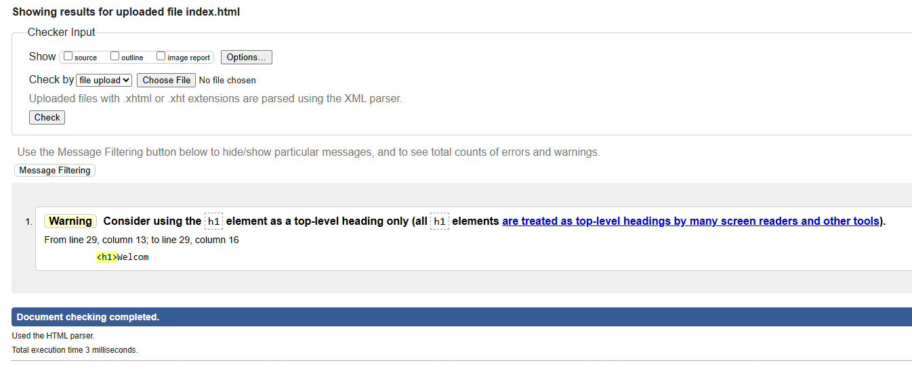

Name of webpage 2 – Computing
(Insert screenshot below)
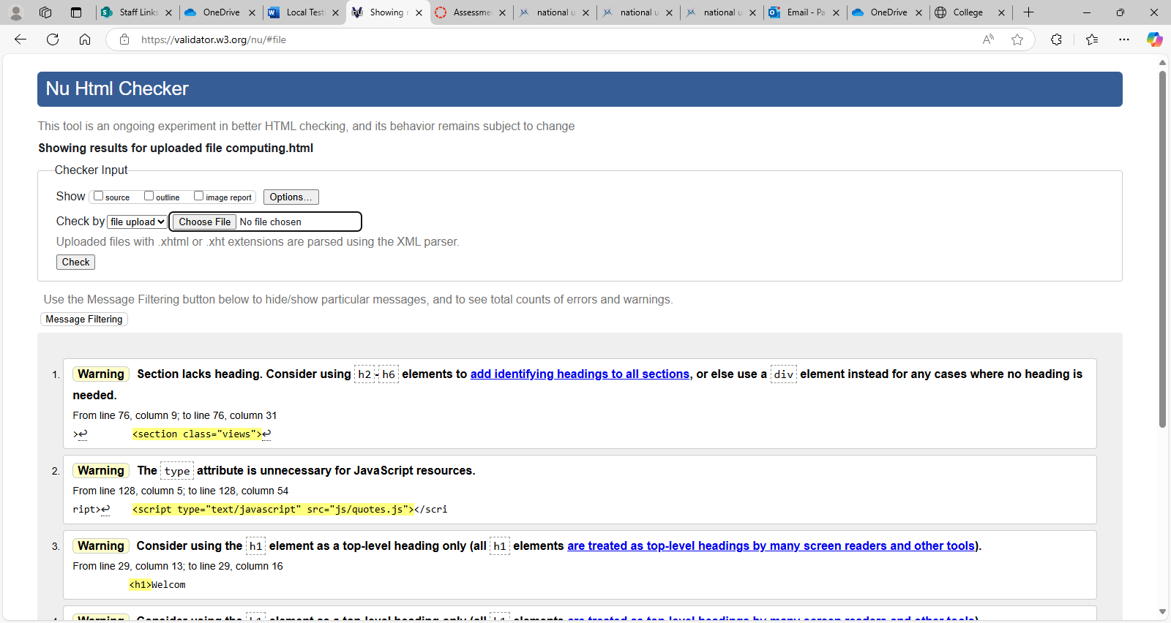

Name of webpage 3 –
(Insert screenshot below)

Name of webpage 4 –
(Insert screenshot below)

Name of webpage 5 –
(Insert screenshot below)

Name of webpage 6 –
(Insert screenshot below)

